**NOAA Ship THOMAS JEFFERSON Procedure Document**

Procedure:

**Patch test**

Creation Date:

8/29/2020

Revision Date:

Software used:

Procedure Number:

**TBD**

Approved:

**TBD**

# Overview and Scope

How to conduct a patch test.

# Procedure Inputs and Outputs

## Inputs:

## Outputs:

# Procedure

The Patch test is best run over a slope or feature. The TJ exclusively runs their patch tests over a feature because of the flat nature of the seafloor on the east coast. Static biases are easier to resolve from data acquired in deeper water.

“Really Shallow Water –in which case the antenna to sonar lever is larger than the sonar to seafloor lever –thus the misalignment with the SRF is the main concern” [1].

“Really Deep Water –in which case the sonar to seafloor lever is larger than the antenna to sonar lever –thus the misalignment with the sonar is the main concern” [1].

The patch tests only tests for the second misalignment “[1]. The first misalignment must be resolved by a vessel survey.

Types of Errors that can be recognized:

* Roll bias
* Pitch bias
* Gyro bias
* Time delay
* Motion time delay
* Incorrect lever arms

“The unknowns are:

* orientation of roll axis with respect to sounder axis.
* orientation of pitch axis with respect to sounder axis.
* orientation of gyro axis with respect to sounder axis.
* time latency between positioning system and sounder” [1]

“Ignoring (or at least minimizing the effect of):

* yaw misalignment of roll and pitch sensor
* time latency in roll
* time latency in pitch
* time latency in gyro
* motion history of RPG
* bandwidth of heave
* tidal errors”[1]

Our goal is to resolve the unknowns. Lines should be planned as seen below. The outer 2 lines are created with a line spacing by using the default line planning method. The inner 5 lines are created with a line spacing of half of the line spacing of the typical line spacing required. The outer 2 lines are not always necessary but can be used to resolve the Gyro axis bias.

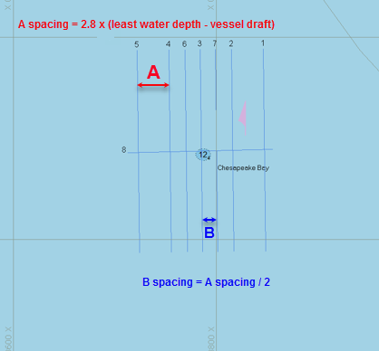

Line number 8 in this example should be run twice in the same direction at different speeds, for example 10kts and 6kts. These 2 lines will be used to resolve the time latency if needed.

All lines should be run twice in opposite directions at normal survey speed. This is to give you enough data to work with if it is hard to visualize the bias in some lines.

Process your MBES as you normally would.

We must resolve static biases in this order:

* + Latency
  + Pitch
  + Gyro axis (Yaw)
  + Roll

This order is used because each bias needs to be resolved independently and this is achieved by resolving each bias in this order.

With your multibeam data open in Caris 11, open up the subset editor and draw your subset over the feature. Be sure to draw the subset with enough flat seafloor selected in order to have data to resolve the roll bias.

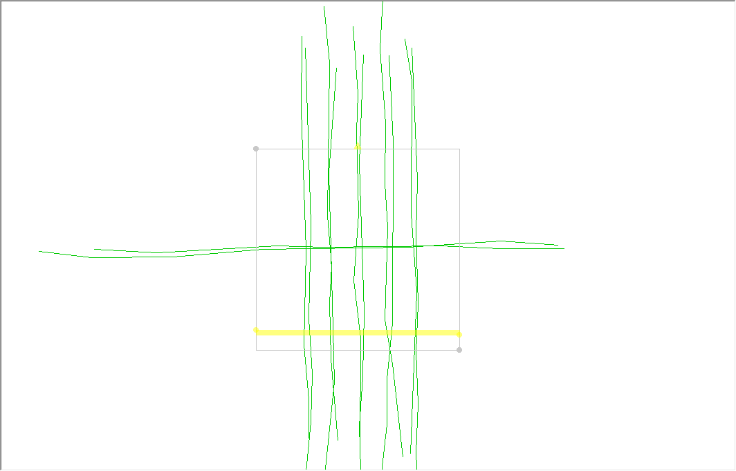

Set your subset up with the color attribute set to Lines, with the color set to Trackline or Trackline_45Colours. We are going to start with latency first. Within the Survey lines window, deselect all lines besides the 2 orthogonal lines that were run for latency (Hypack line 8 in the example plan above). Set your “cheese slice” to be over the feature in the along track direction so you are looking in the across track direction within the center of the 2 latency lines (see image below).

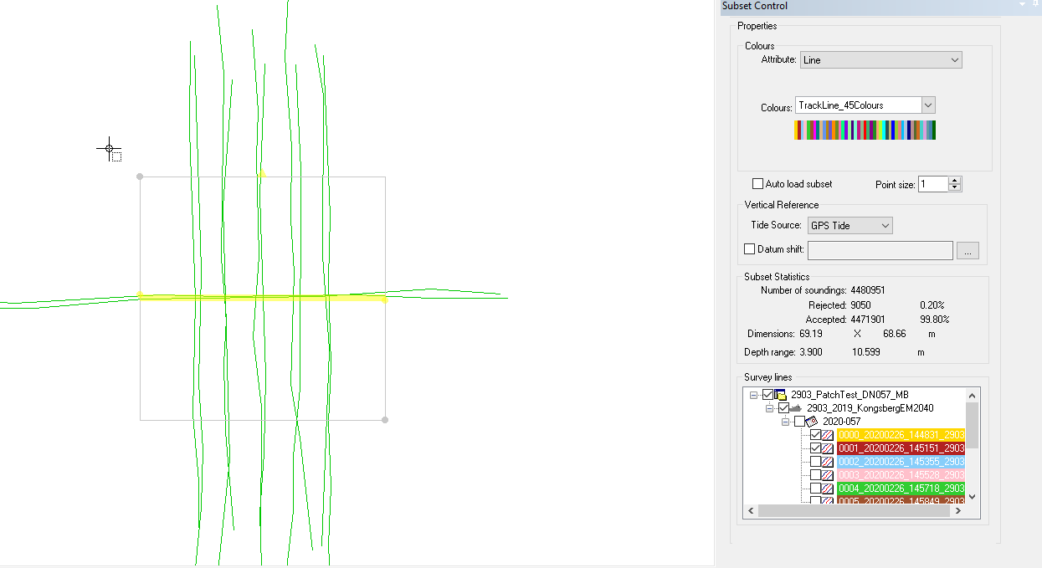

With that set, Select Calibration under the data window of the subset control and click Start.

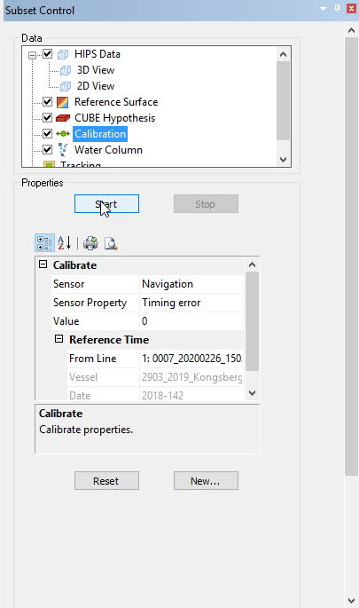

Once Calibration has loaded, make sure the “Calibrate” setting for “Sensor” is set to Navigation and the “Sensor Property” is set to “Timing Error”.

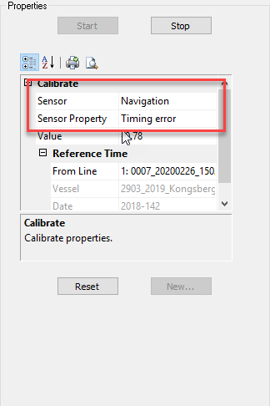

Within the 2d View window use the green dot on the slide bar to adjust the values until your 2 lines of different colored pings match up. It is always good to slide the green dot to a large value when calibrating for a static bias just to get an idea of how it’s going to affect your data when you change the values.

With PPS timing latency should not be an issue. If you are seeing a latency offset check to see if PPS is being distributed to your sonar.

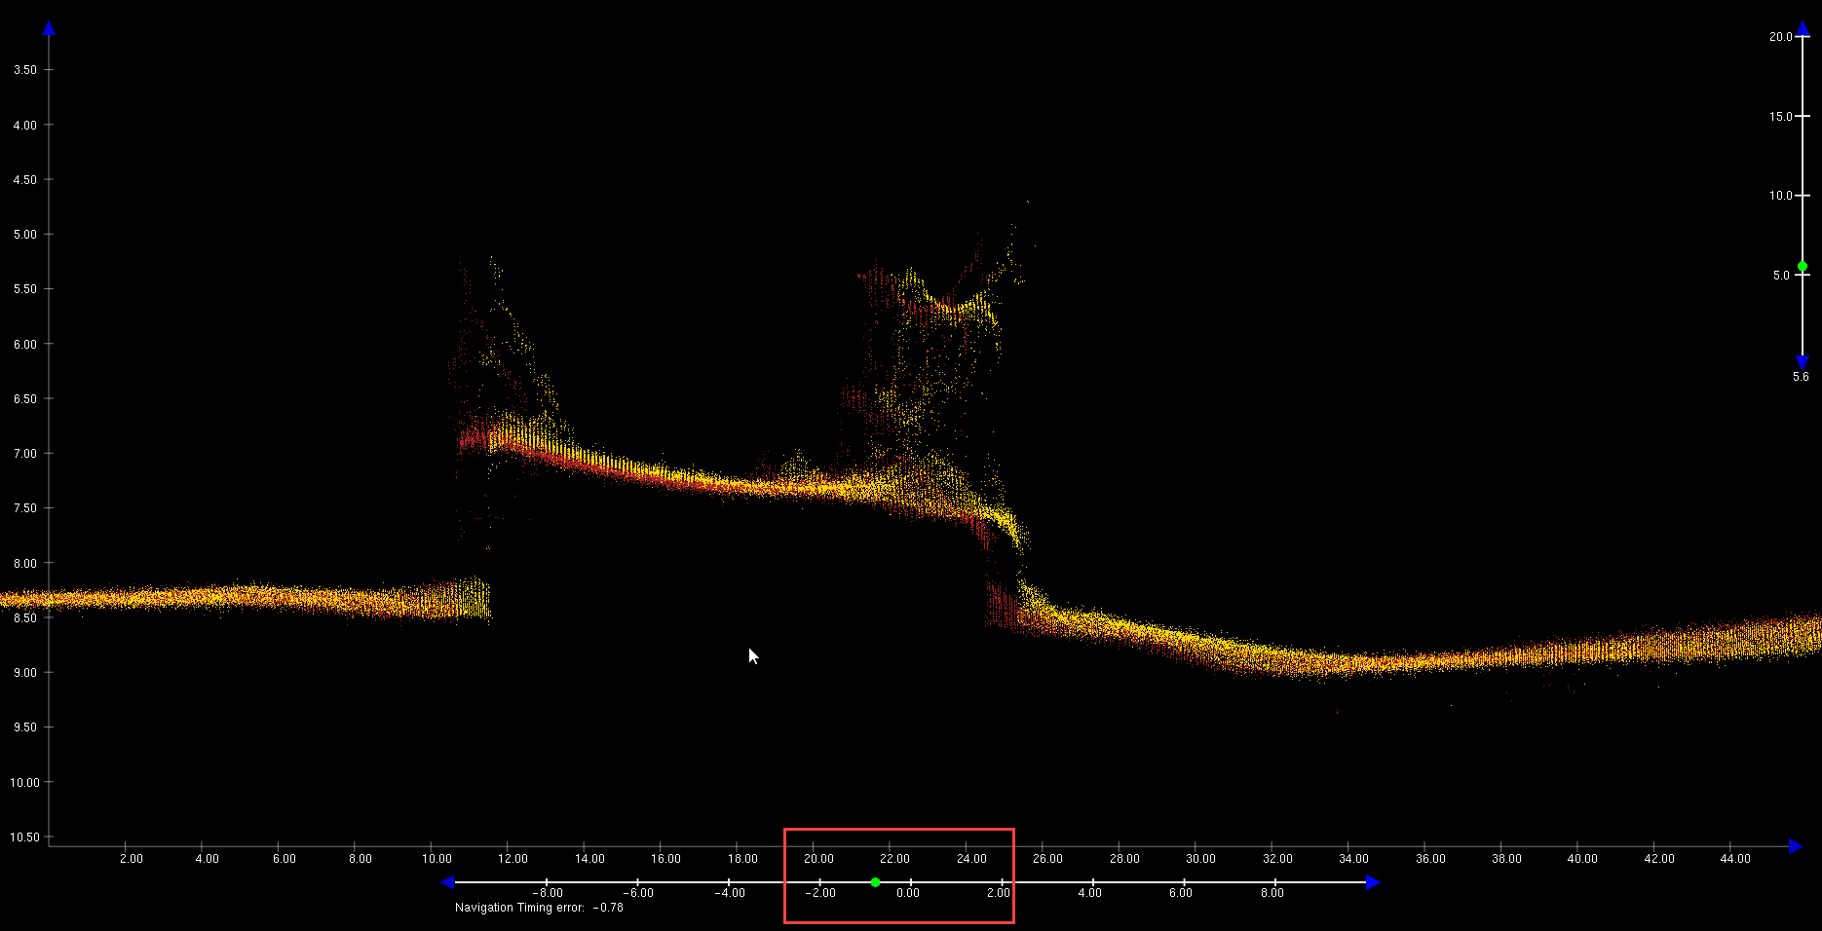

If no latency is observed (as is normal), set this value back to zero and change your Sensor to Transducer 1. If Latency is observed leave the value set and change your Sensor to Transducer 1. Record your value and the lines used to arrive at that value on a sheet of paper or in a text document. We will record these values into a spreadsheet at the end. The reason we don’t do this now is because you do not want to be influenced by another’s values for the experiment and we need at least 5 people to conduct the patch calibration within Caris in order to average them for a final value. Someone may have already entered their values within the spreadsheet and it will negatively influence your observations of the static offset values.

**Pitch:** Select “Hips Data” under the Data window of the subset control. Within the “Survey lines” window, deselect all lines besides 2 lines over the feature that were run in opposite directions over each other (the two lines run over Hypack line 3 in the example above). We are going to resolve the pitch static bias. Set your “cheese slice” to be over the feature in the along track direction so you are looking in the across track direction within the center of the 2 pitch lines (see image below).

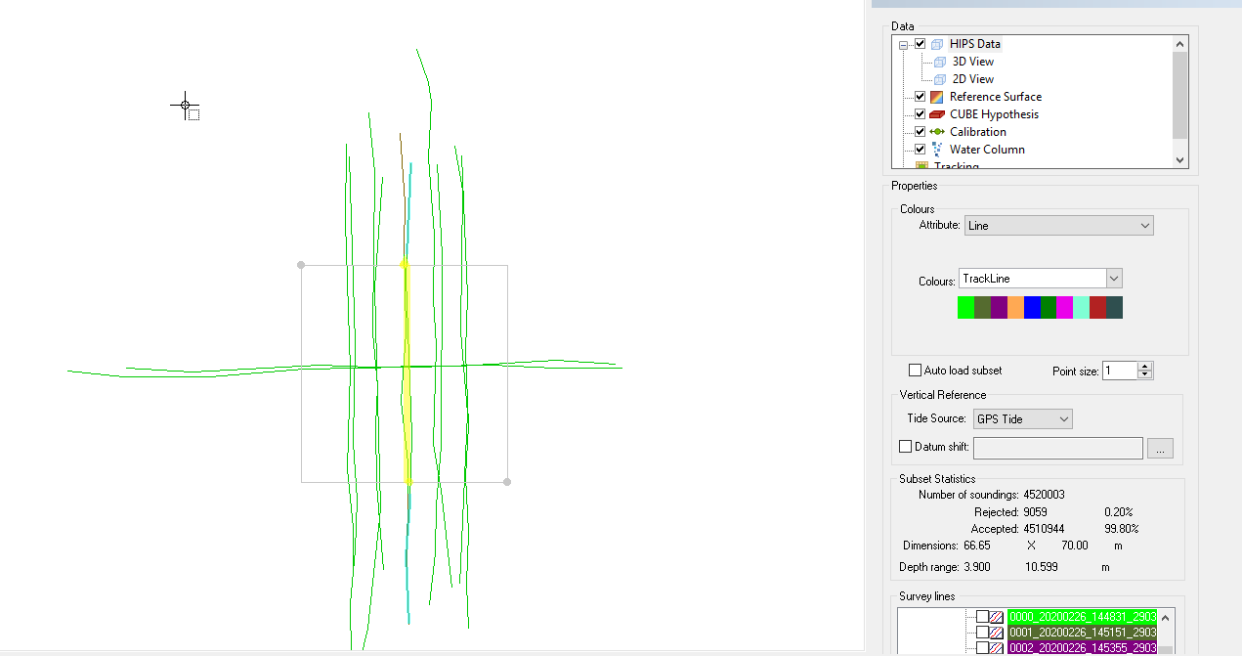

With that set, select “Calibration” under the “Data” window of the subset control and set “Sensor Property” to “Pitch error”. You can use the right and left arrow keys on your keyboard to scroll through the data if your subset is set up similar to the image above with the subset window facing north within the display window and orientating your “cheese slice” independent of the subset direction. Within the 2d View window, slide the green dot to a large value in order to get an idea of how it’s going to affect your data when you change the values. Use the green dot on the slide bar to adjust the values until your 2 lines of different colored pings match up. If it is hard to visualize use your arrow keys to scroll through the data until it is apparent or select 2 other lines that fit the requirements. Record your value and the lines used to arrive at that value on a sheet of paper or in a text document. Leave the pitch value set and change your “Sensor Property” to “Yaw error”.

**Yaw:** Select “Hips Data” under the “Data” window of the subset control. For Gyro axis calibration you need 2 lines with the same heading with about 10 to 20% overlap in the outerbeams. Within the “Survey lines” window, deselect all lines besides your 2 yaw lines under the “Survey lines” window. We are going to resolve the yaw static bias. Set your “cheese slice” to be over the feature in the along track direction so you are looking in the across track direction between the 2 yaw lines (see image below).

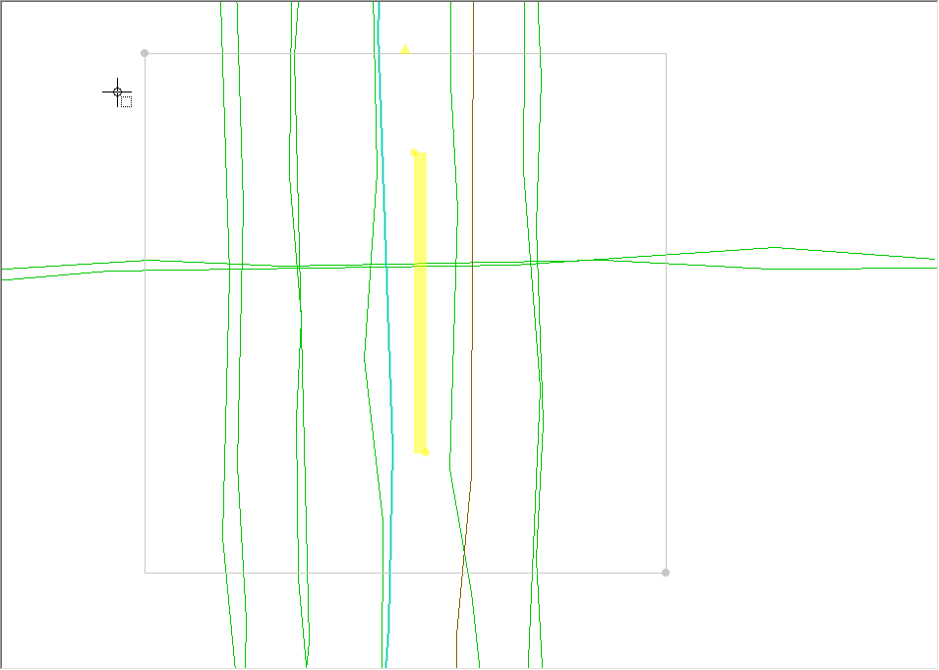

With that set, select “Calibration” under the “Data” window of the subset control. Under the “Calibrate” window the “Sensor Property” should be set to “Yaw error”. You can use the right and left arrow keys on your keyboard to scroll through the data if your subset is setup similar to the image above with the subset window facing north of the display window and orientating your “cheese slice” independent of the subset direction. Within the 2d View window slide the green dot to a large value in order to get an idea of how it’s going to affect your data when you change the values. Use the green dot on the slide bar to adjust the values until your 2 lines of different colored pings match up. If it is hard to visualize use your arrow keys to scroll through the data until it is apparent or select 2 other lines that fit the requirements. Record your value and the lines used to arrive at that value on a sheet of paper or in a text document. Leave the yaw value set and change your “Sensor Property” to “Roll error”.

**Roll:** Select “Hips Data” under the “Data” window of the subset control. For roll calibration you need to select 2 lines over the feature that were run in opposite directions on top of each other. Within the “Survey lines” window, deselect all lines besides your 2 roll lines. We are going to resolve the roll static bias. Set your “cheese slice” to be over a flat seafloor in the across track direction so you are looking in the along track direction within the center of the 2 roll lines (see image below). Within the 2d View window slide the green dot to a large value in order to get an idea of how it’s going to affect your data when you change the values. Use the green dot on the slide bar to adjust the values until your 2 lines of different colored pings match up. If it is hard to visualize use your arrow keys to scroll through the data until it is apparent or select 2 other lines that fit the requirements. Try to use the center of the lines to resolve your roll bias because your outerbeams may be affected by refraction. Roll is incredibly hard to resolve in shallow water. You may find a roll bias still present as you get on project. Do not be afraid to adjust your roll offset to correct for it while on project (CHST only, refer to SOP "K:\Standard_Operating_Procedures\05_HSRR\2022 - How and where to enter your patch values.docx" to help you update your values while on project). Record your value and the lines used to arrive at that value on a sheet of paper or in a text document.

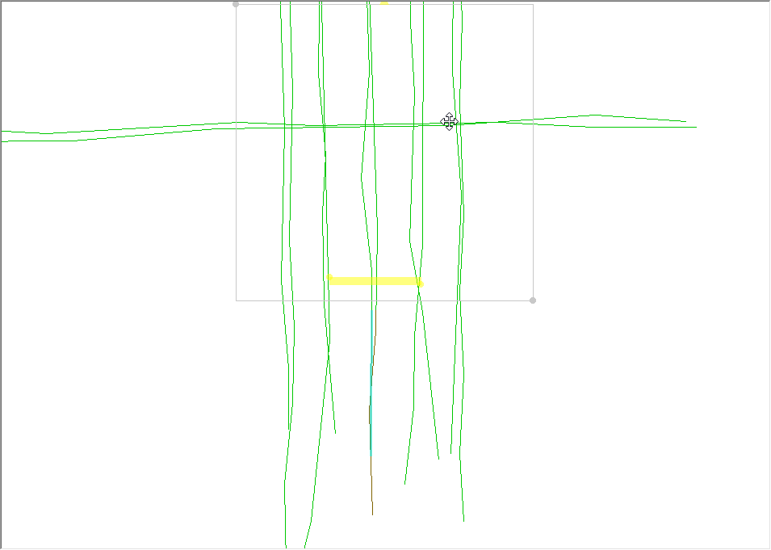

You have now finished your patch test. Close out of the Subset window and **DO NOT** save changes to ‘Subset Editor’. 5 or more people need to conduct the same experiment and you do not want to negatively influence someone else’s observations of the static offset values.

Open up the spread sheet found at "K:\Standard_Operating_Procedures\05_HSRR\Reference Files\Vessel_Sonar_MBES_Patch_2020.xlsx" or a spreadsheet that has already been saved from this spread sheet and enter your values into the appropriate cells. Do not save your values into the spread sheet under the SOP Reference Files folder as this is the default spreadsheet. Save the spread sheet under the appropriate HSRR folder. This spread sheet will keep your values recorded, average them for a final value, and give you the standard deviation for your HVF.

Refer to SOP "K:\Standard_Operating_Procedures\05_HSRR\2022 - How and where to enter your patch values.docx" to know where you should enter your values and how to properly update your hvf.

# References

1. "N:\Survey\Training\Shallow Multibeam_Training_Course\2020\MBC79_LecturesNotes\Lecture_PDFs\79L24_patch_MBC_2020.pdf"
2. "K:\Standard_Operating_Procedures\05_HSRR\Reference Files\Vessel_Sonar_MBES_Patch_2020.xlsx"
3. "K:\Standard_Operating_Procedures\05_HSRR\2020 - How and where to enter your patch values.docx"